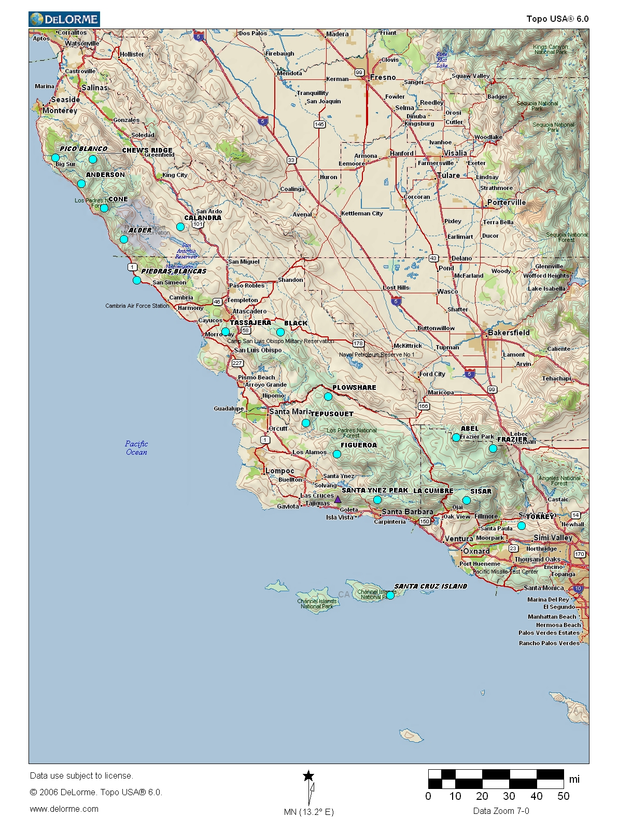

Los Padres National Forest Frequencies and Tones
CH | Groups 1, 2, 3, 4 & 5 | RX | TX | Repeater > | R5 Tone
1 | Forest Net Repeat > | 170.4625 | 164.9125 | Frazier | 110.9 | 1
2 | Admin Net Repeat > | 171.5500 | 164.1500 | Siser | 123.0 | 2
3 | Forest Net F3 | 170.4750 | 170.4750 | La Cumbre | 131.8 | 3
4 | Varies by Group |  |  | Alder | 136.5 | 4
5 | R5 Crew Net | 168.2000 | 168.2000 | Black Mtn. | 146.2 | 5
6 | Air / Ground | 167.4750 | 167.4750 | Torrey Hill | 156.7 | 6
7 | Varies by Group |  |  | Mt. Pinos (Abel) | 167.9 | 7
8 | Varies by Group |  |  | Cone Pk / Santa Ynez Pk | 103.5 | 8
CH | Groups 6*, 7, 8 & 9 | RX | TX | Tassajera | 100.0 | 9
1 | Forest Net F1 *>8 | 170.4625 | 170.4625 | Chews Ridge | 107.2 | 10
2 | Forest Net Repeat > | 170.1625 | 164.9125 | Plowshare | 114.8 | 11
3 | Forest Net F3 | 170.4750 | 170.4750 | Tepusquet | 127.3 | 12
4 | Forest Net F4 | 172.3500 | 172.3500 | Anderson | 141.3 | 13
5 | R5 Crew Net | 168.2000 | 168.2000 | Figueroa | 151.4 | 14
6 | Air / Ground | 167.4750 | 167.4750
7 | Admin Net F1 *>8 | 171.5500 | 171.5500
8 | Admin Net Repeat > | 171.5500 | 164.1500 | *>8 Use Tone 8 for Forest /Admin Net F1 Direct

